ISAIAH 62 PRAYER INITIATIVE
May 2018 Prayer Letter

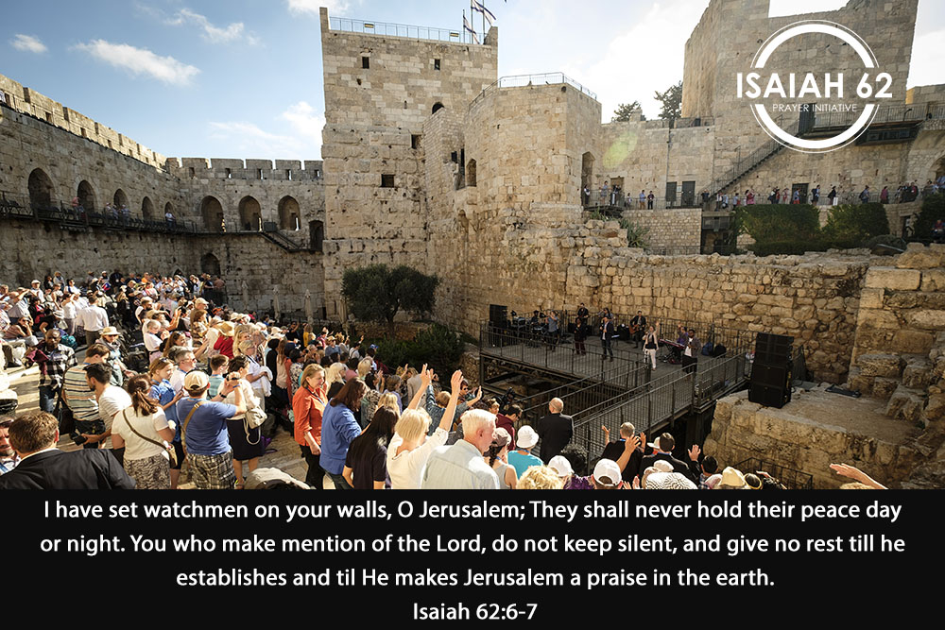

Dear prayer partners,
Thank you for joining us in this Isaiah 62 prayer initiative. During the month of May, let us revisit some foundational verses of the ICEJ:
For Zion’s sake I will not hold My peace, And for Jerusalem’s sake I will not rest, Until her righteousness goes forth as brightness, And her salvation as a lamp that burns. The Gentiles shall see your righteousness, and all Kings your glory. (Isaiah 62:1-2)
Indeed the Lord has proclaimed to the end of the world: “Say to the daughter of Zion, ‘Surely your salvation is coming; Behold, His reward is with Him, And His work before Him.’” And they shall call them The Holy People, The Redeemed of the Lord;
And you shall be called Sought Out, A City Not Forsaken. (Isaiah 62:11-12)
Scripture tells us to give our Lord no rest until HE makes Jerusalem a Praise in all the earth.
This month the world focuses its attention on the US Embassy moving to Jerusalem. Following suit, the government of Guatemala has announced that it also intends to move its embassy to Jerusalem. We are also aware that Honduras, Romania and the Czech Republic will soon be moving their embassies to Jerusalem, but we are waiting to see who will be the first to take action.
May 2018 is a month where the world will be viewing Jerusalem in a new way. For the first time since the resurrection of Israel 70 years ago, nations are beginning to speak of Jerusalem as the capital of Israel. Positive words are being spoken about Jerusalem among the nations, and we are privileged by our Lord to see the beginning of God making Jerusalem a praise in all the earth.
Isaiah 62 also tells us that this is part of our Lord’s process of revealing his righteousness, His glory and His salvation to the Gentile nations. Therefore as we continually come before Him in prayer, reminding Him of His promise to make Jerusalem a praise in all the earth, we should also remind Him to bring Salvation in Jesus to the nations.
Not long ago, I was in a meeting where a rabbi was addressing Christians, and he referred to verses that speak about watchmen on the wall, like Isaiah 62:6. However, he read Jeremiah 31:6 because the Hebrew word used here for watchman is also the modern Hebrew word for Christian. I agree with his conclusion: “God foresaw the time when He would call Christians to be the watchmen who stand on the spiritual wall of Israel day and night praying for Him to fulfill His promises to Israel and the Jewish people.”
As God is making Jerusalem a praise in all the earth, we should also see that His Salvation is coming to His people. In Ezekiel 36, God says He will take out the heart of stone, put in a heart of flesh and then pour out His Spirit on His people He brought back to Israel.
On May 2nd, we here in Jerusalem will be fasting and praying for God to continue to move to make Jerusalem a praise in all the Earth. Join us by taking a meal time to focus your heart, mind and soul on our Lord and His promises, as you say through your fasting; “Lord Your word and Your promises are more important to me than my hunger and food.”
Do not be quiet, you who call on the Lord, give Him no rest until He makes Jerusalem a praise in the earth.
Thank you for being a part of our Isaiah62 prayer movement!
Blessed be the name of our Lord Jesus,
Barry R Denison
Vice President Operations
International Christian Embassy Jerusalem

PRAYER POINTS
For May 2018
The next day of prayer and fasting in our Isaiah 62 Global Prayer Campaign will be on Wednesday, 2 May 2018. Please join us!
Pray with us accordingly:
- Prayer for Israel

International Celebration of Israel’s 70th Anniversary
Pray for the nations around the world to stand with Israel this May 14th for the international celebration of Israel’s 70th year since its rebirth as a nation in 1948.
“All nations whom You have made shall come and worship before You, O Lord,
and shall glorify Your name.” (Psalm 86:9)

US Embassy Moving to Jerusalem
The US Embassy is making a big move to Jerusalem, declaring to the world that the United States of America sees Jerusalem as the capital city of Israel! Please pray for protection over the city of Jerusalem, as we wait to see how the people in Jerusalem and the world will respond to this move.
“Pray for the peace of Jerusalem: May they prosper who love you.” (Psalm 122:6)

Aliyah and Absorption
Pray for more open doors for Jews from all around the world to come back to their promised land of Israel. Also, please continue to pray for the integration process for the 1,300 new Ethiopian immigrants that the ICEJ has helped make Aliyah to Israel this past year.

“Fear not, for I am with you; I will bring your descendants from the east, And gather you from the west; I will say to the north, ‘Give them up!’ And to the south, ‘Do not keep them back!’ Bring My sons from afar, And My daughters from the ends of the earth.” (Isaiah 43:5-6)

2. Prayer for the Nations

Embassies
Guatemala, the Czech Republic, Honduras, Romania, and Paraguay are strongly considering moving their embassies to Jerusalem as well. Pray that God will lead many other nations to move their embassies to Jerusalem, which will show that they recognize Jerusalem as the capital of Israel.

“Yes, many peoples and strong nations shall come to seek the Lord of hosts in Jerusalem, And to pray before the Lord.” (Zechariah 8:22)

Iran and Israel Relations
A few weeks ago a drone was sent over Israeli borders, and in defense the IDF shot down a missile at an Iranian military base in Syria, killing 14. Therefore, this month may be one of heightened tension between Israel and Iran. Pray for God to thwart the plans of the enemy and for God to shield and protect against bloodshed.
“Our soul waits for the Lord; He is our help and our shield.” (Psalm 33:20)

Celebrating Pentecost
According to Jewish tradition, during Pentecost or Shavout, God came down in fire on Mt. Sinai giving Moses the Torah. As the prophet Jeremiah explained, God is promising a new season for Israel and the whole world to have the laws of God written on their hearts, which is done by the filling of the Holy Spirit. Pray for the children of God to hear what the Spirit is saying and to move in the power of God’s Spirit. Pray for God to pour out His Spirit in a mighty way this month, as we celebrate Pentecost on May 20th.

“But this is the covenant that I will make with the house of Israel after those days, says the Lord: I will put My law in their minds, and write it on their hearts; and I will be their God, and they shall be My people.” (Jeremiah 31:33)

So he answered and said to me: “This is the word of the Lord to Zerubbabel: ‘Not by might nor by power, but by My Spirit,’ Says the Lord of hosts. (Zechariah 4:6)

- Prayer for the ICEJ

ICEJ Headquarters
Since its beginning, the ICEJ has always rented property for God’s work here in Jerusalem. In this last year, the Lord has moved the hearts of the ICEJ leadership to purchase a property suitable for the vision of the ICEJ and the development of the future work God wants to do in and through the ICEJ. Please pray for wisdom, favour, and grace in this new development.
“Through wisdom a house is built, And by understanding it is established; By knowledge the rooms are filled with all precious and pleasant riches.” (Proverbs 24:3-4)

ICEJ Prayer Wave
The ICEJ is getting ready to expand the Isaiah 62 prayer initiative into a 24-7 prayer dynamic all around the globe. The Lord gave us the vision of Him establishing a 24-hour prayer wave that circles the earth unifying the nations to meet the dawning of the morning in the place of intercession for Israel, revival, communites and personal needs. Please pray for this initiative to connect the body of Christ around the world to pray in one accord for every aspect of the restoration of Israel and Jerusalem, in accordance to Isaiah 62:1-7.

“From the rising of the sun to its going down the Lord’s name is to be praised.” (Psalm 113:3)

Feast of Tabernacles
This Feast will be a powerful one as we “Dare to Dream” with the God of Israel in the promised land. Please pray for God to provide 250 Feast Team members to help us make this Feast of Tabernacles a time to celebrate God bringing many dreams to reality!
If you are interested in serving at the Feast this year, please sign up at: feast.icej.org/feast-team
“When the Lord brought back the captivity of Zion, We were like those who dream.” (Psalm 126:1)
Thank you for joining with us in prayer!

