ISAIAH 62 PRAYER INITIATIVE
June 2018 Prayer Letter

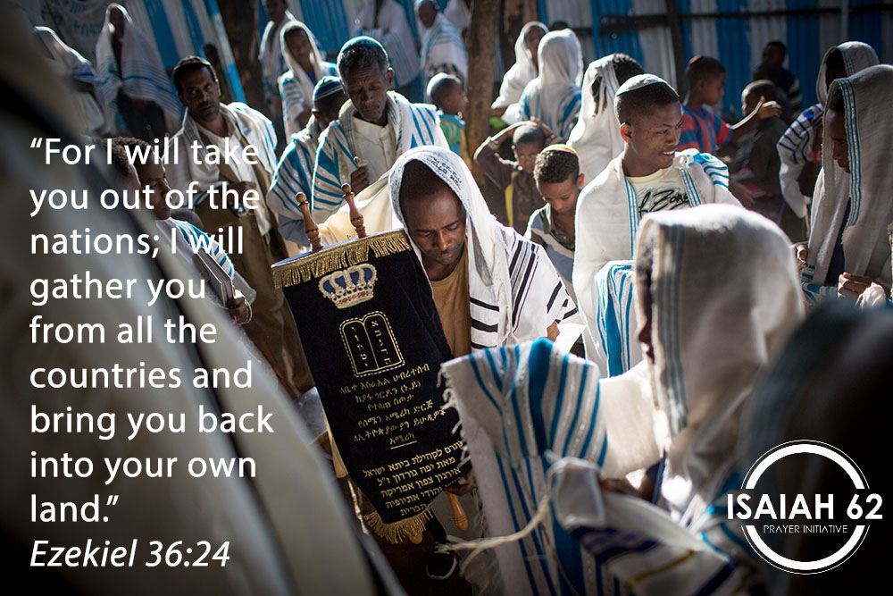

Dear prayer partners,
Recently, I have been reading through the “small prophets”, and it struck me how consistently they bring the message of both judgment and the return of the Jews from exile to their ancient homeland. Here are just a few verses:
“… the children of Judah and the children of Israel shall be gathered together.” (Hos 1:11)
“Be glad, O children of Zion, and rejoice in the Lord your God … you shall praise the name of the Lord your God, who has dealt wondrously with you. And my people shall never again be put to shame.” (Joel 2:23)
“I will bring back the captives of my people Israel; they shall build the waste cities and inhabit them; they shall plant vineyards and drink wine from them; they shall also make gardens and eat fruit from them. I will plant them in their land, and no longer shall they be pulled up from the land I have given them, says the Lord your God.” (Amos 9:14-15)
“At that time, I will bring you back, even at the time I gather you; for I will give you fame and praise among all the peoples of the earth, when I return your captives before your eyes.” (Zeph. 3:20)
Together with numerous Scriptures in the books of Isaiah, Jeremiah and Ezekiel, the Bible presents a very clear picture of God judging His people strictly, and the ultimate judgment is their uprooting from the Land and dispersion among the nations. However, God will eventually have mercy and bring the people back to the Land. There, He will deal with them, cleanse them and redeem them (Ezek. 36:24-28).
We are privileged to live in a time when the restoration of Israel is evident and unfolding before our eyes. It is no longer a mystery, something our forefathers struggled to understand and interpret correctly. For centuries, the church even taught that these Scriptures could not be taken literally, and they were applied to Gentile believers in an allegorical sense. The Jews were thought to have been punished by God forever, and the Land of Israel was no longer considered relevant.
On the other hand, the Jewish people never ceased praying for the return to Zion. Throughout their exile, they remembered the destruction of the Temple and kept the hope of return alive. Perhaps nothing symbolizes this hope better than the sentence which has been uttered for centuries every year at the end of the Seder meal, inaugurating the Feast of Passover: “Next year in Jerusalem!”
Today, the Jewish state is a reality that no one can deny. The Jews have returned to Zion, and the Bible says that it also has significance for the nations. When the Lord brings the Jews back from exile, “the nations will know that I am the Lord.” (Ezek. 36:23) In fact, the nations have a great role to play in spreading the message.
The Prophet Jeremiah says: “Hear the word of the Lord, O nations, and declare it in the isles afar off, and say, ‘He who scattered Israel will gather him, and keep him as a shepherd does his flock.’” (Jer. 31:10)
It is our mission to declare the magnificent deeds of our God concerning Israel to the isles afar off. Our new prayer initiative, the PrayerWave, is intended to accomplish just that: every morning, every day and in every time zone, God’s will regarding Israel will be declared. Please join us in this new and exciting endeavor. Give God no rest until He establishes Jerusalem and makes it a praise in the Earth. Go to ICEJPrayerWave.com and register today to become part of our global praying family.
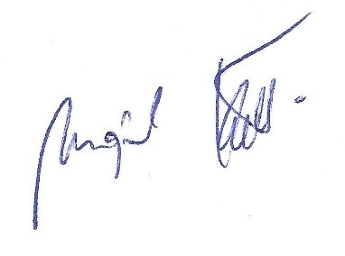
Shalom from Jerusalem,

Mojmir Kallus
Vice President – International Affairs
International Christian Embassy Jerusalem

