ISAIAH 62 PRAYER INITIATIVE
August 2018 Prayer Letter

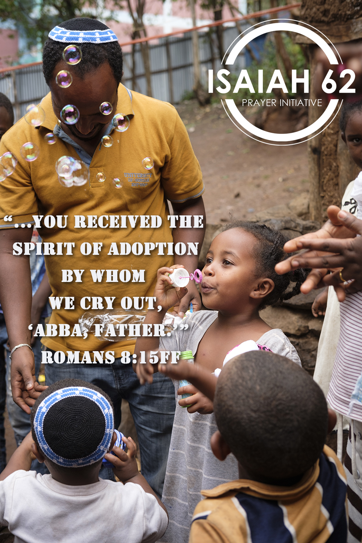
Dear Prayer Partners,
The ICEJ defines itself as a ministry of intercessors. Prayer has been the driving force of our ministry from the very beginning. Time and again, the Lord leads us back to this fundamental trait. This is how the Isaiah 62 initiative was born, as well as the new Prayer Wave initiative.
There are many ways we can pray and many models we can find in the Bible. One of them is the instruction Jesus gave to His disciples in Matthew 6. He instilled faith in them by assuring them that the Father already knows all their needs before they even asked Him. Then, He continued to lay down what is known as the Lord’s prayer. These short lines can be seen as a set of priorities for our prayer life.
In this prayer letter, I will share a few thoughts and invite you to meditate on the text yourselves.
The Lord’s prayer starts by addressing God as our Father. He is not a distant God who is not interested in our affairs, instead we can relate to Him as to a family member. Paul underlines this by using the word “Abba”, which literally means “Daddy”. When I see little children on the street or at the beach in Israel saying, “Abba!” and running to the father, I am always reminded of this close relationship of trust that God wants to have with us.
If we received Jesus as our Savior we received the Spirit of adoption by whom we cry out, “Abba Father.” We are not slaves, we did not receive the spirit of bondage and fear (Rom 8:15-16, Gal 4:6-7). The very beginning of the Lord’s prayer puts us in a place of trust and safety. No matter what goes on in our lives, our loving Father knows about it and tells us: “Fear not, for I am with you.”
Living as children of God also has implications for our behavior. Paul says in Romans 8:11-14:
But if the Spirit of Him who raised Jesus from the dead dwells in you, He who raised Christ from the dead will also give life to your mortal bodies through His Spirit who dwells in you. Therefore, brethren, we are debtors—not to the flesh, to live according to the flesh. For if you live according to the flesh you will die; but if by the Spirit you put to death the deeds of the body, you will live. For as many as are led by the Spirit of God, these are sons of God.
The sign of sonship is that we are led by the Spirit. How do we recognize it? By not living according to the flesh. This entails resisting sin, fighting temptation, and enduring chastening:
For whom the Lord loves He chastens and scourges every son whom He receives. If you endure chastening, God deals with you as with sons; for what son is there whom a father does not chasten? But if you are without chastening, of which all have become partakers, then you are illegitimate and not sons. (Heb 12:6-8)
Therefore, when we start to pray, we recall that we are in a place of complete safety because He is our Father. We have His Spirit in us, and strive to live according to the Spirit. We must guard our path and receive chastisement, unlike the sons of the world. When we concentrate on His name and His kingdom first, we are inspired to search the motives of our hearts. Whose name should be glorified? “Not unto us, O Lord, not unto us, but to Your name give glory” (Psalm 115:1). The story of the tower of Babel teaches us that there may be lofty goals, great unity, efficient methods, advanced technologies, and yet it may end up displeasing the Lord if we say in our hearts: “let us make a name for ourselves” (Genesis 11:4ff).
Praying for His kingdom to come means focusing on the big picture. God’s Kingdom is much more than just our personal life or church life. It encompasses all of society. God wants us to bring Kingdom values to this world wherever we are: in the marketplace, in art, at school, at home, and with friends. When we pray for His Kingdom to come, we must expect to be used by Him and for Him.
God chose Israel to be His model Kingdom and He will accomplish His plan. This is why all Israel will be saved. Jesus will restore the kingdom to Israel (Acts 1:6), and we are called to pray as watchmen and give Him no rest until he makes Jerusalem a praise in the earth (Isaiah 62:6-7).
This is a place to pray for your country, too. God will judge the nations (Mt 25:31ff) and the measuring stick will be how they related to the Jewish people and to the land of Israel (Joel 3:1-2). Let us pray for our nations and our leaders.
Prayer has the power to change history! May God give you revelation as you continue praying according to the Lord’s prayer.
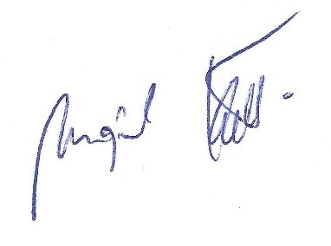
Shalom from Jerusalem,

Mojmir Kallus
Vice President – International Affairs
International Christian Embassy Jerusalem

PRAYER POINTS
For August 2018
The next day of prayer and fasting in our Isaiah 62 Global Prayer Campaign will be on Wednesday, August 1st, 2018. Please join us!
Pray with us accordingly:
- Prayer for Israel

Israel in Crisis
The security situation on Israel's borders is very fragile. Iranian proxy terrorist groups in the Gaza Strip continue to harass Israel with arson attacks involving incendiary kites and balloons, as well as occasional barrages of rockets. Please continue to pray for God to move powerfully in the Israeli communities along the Gaza border as they continue to face daily fires and frequent rocket attacks. Pray that the ICEJ would have the funds to provide meaningful and timely assistance to Israelis in the their time of need.
“When you pass through the waters, I will be with you; And through the rivers, they shall not overflow you. When you walk through the fire, you shall not be burned, Nor shall the flame scorch you. For I am the Lord your God, the Holy One of Israel, your Savior…” (Isaiah 43: 2-3ff)
“The thief comes only to steal and kill and destroy; I have come that they may have life, and have it to the full.” (John 10:10 NIV)
Aliyah – The Fulfillment of God’s Word
At the end of July, ICEJ staff witnessed 300 new Jewish immigrants from Argentina, Brazil, France, and Russia arrive at Ben-Gurion Airport. As soon as they deboarded the plane, they were welcomed to their new home by hundreds of family members, excited Israelis, and Christians cheering and celebrating their new beginning. It is incredible to see the fulfilment of God’s word happen right before our eyes. Please continue to pray for God to stir the hearts of His Jewish people to take the leap of faith to make their home in the land of their forefathers.
“… but, ‘The Lord lives who brought up the children of Israel from the land of the north and from all the lands where He had driven them.’ For I will bring them back into their land which I gave to their fathers.” (Jeremiah 16:15)
“He will set up a banner for the nations, And will assemble the outcasts of Israel, And gather together the dispersed of Judah from the four corners of the earth.” (Isaiah 11:12)
Jewish Nation-State Bill
Israel's Knesset recently passed the "Jewish Nation-State Bill" codifying in law the Jewish character of the State. This new law has led to a backlash by Jewish Diaspora communities in Western countries, further dividing those communities and Israel. In addition, the new law could potentially be exploited to harm Messianic Jewish communities in Israel, as well as Arab Christians and other minorities. Pray for great wisdom for the leaders in all of these communities to know how to proceed in the new reality this law has created.

“Now give me wisdom and knowledge, that I may go out and come in before this people; for who can judge this great people of Yours?” (2 Chronicles 1:10)

“If any of you lacks wisdom, let him ask of God, who gives to all liberally and without reproach, and it will be given to him.” (James 1:5)

2. Prayer for the Nations

Syria & Israel’s Northern Border
The Assad regime in Syria continues to re-take territory from rebel factions near the Israeli border, giving rise to the threat of violence spilling over into Israel. The IDF has shot down several aircraft (jets and drones) violating its airspace from Syria in recent weeks, underlining this threat. In addition, Israel continues to strike Iranian military targets throughout Syria. Israel’s objection to the growing Iranian military presence inside Syria has become a core issue in talks between US and Russian leaders over recent weeks. Finally, many Syrian civilians stranded along the border with Israel are desperate for Israel’s assistance. Pray for God to reveal Himself to the Syrians who are running to Israel for help. Pray for God to continue to guard and protect the boundaries He has put in place over the land of Israel.
“And He has made from one blood every nation of men to dwell on all the face of the earth, and has determined their preappointed times and the boundaries of their dwellings, so that they should seek the Lord, in the hope that they might grope for Him and find Him, though He is not far from each one of us.” (Acts 17:26-27)
“When the Most High divided their inheritance to the nations, when He separated the sons of Adam, He set the boundaries of the peoples according to the number of the children of Israel.”
The Need for Water
Israel and the surrounding countries continue to suffer from an ongoing drought and searing heat wave. This long-term increase in temperatures and decrease in precipitation has already contributed to multiple problems for several countries in the region, and those problems are likely to get worse. If not for the desalinization plants Israel began building in the late 1990s, Israel itself would already have begun to suffer acute water shortages. Two additional plants are currently under construction to keep up with the demand for water. Please pray for God to pour out his refreshing rains on Israel and the countries in great need of water.
“Sing to the Lord with thanksgiving; Sing praises on the harp to our God, Who covers the heavens with clouds, Who prepares rain for the earth, Who makes grass to grow on the mountains.” (Psalm 147:7-8)
“For I will pour water on him who is thirsty, and floods on the dry ground; I will pour My Spirit on your descendants, and My blessing on your offspring.” (Isaiah 43:3)

Regional Realignment
There are many indications that the Arab world is starting to open up to Israel and their own need to normalize relations with the Jewish state. Key Arab leaders and other important voices are saying the future of the region should no longer be held hostage to the Israeli-Palestinian conflict, and they are urging the Palestinians to finally be willing to compromise for peace. The rising threat of a nuclear Iran is also driving Israel and these Arab nations closer together. Pray that this trend would continue, that the leaders and people of Egypt, Jordan, Saudi Arabia and the Gulf states would truly reconcile themselves to Israel’s rightful place in the region, and that they would sway the Palestinians to do the same.

“The Lord will give strength to His people; The Lord will bless His people with peace.” (Psalm 29:11)
“When a man’s ways please the Lord, He makes even his enemies to be at peace with him.” (Proverbs 16:7)

- Prayer for the ICEJ

New ICEJ office in Haifa Home
At the end of July, ICEJ AID’s deputy director Yudit Setz moved to Haifa to open ICEJ’s first branch office in Israel outside Jerusalem. The new ICEJ office is connected to the Haifa Home for Holocaust Survivors, and it the base from which Yudit will coordinate long and short-term Christian volunteers to better serve and comfort these precious Holocaust survivors. Pray for this new office to have a smooth and strong beginning, as God continues to minister His love for the Jewish people through ICEJ. Pray for God’s grace and favor over Yudit Setz and her family as they transition into their new home and assignment in Haifa.

“Do not despise these small beginnings, for the Lord rejoices to see the work begin, to see the plumb line in Zerubbabel’s hand.” (Zechariah 4:10 NLT)

“The grace of the Lord Jesus Christ be with your spirit. Amen.” (Philippians 4:23 NIV)

ICEJ Headquarters
Over the past year, the Lord has put it on the hearts of the ICEJ leadership to purchase the property which our ministry currently leases as our global headquarters in Jerusalem. Please continue to pray for God’s guidance and favour in this matter. Pray in particular for our dealings with our landlord, the government of the Ivory Coast.

“However, when He, the Spirit of truth, has come, He will guide you into all truth; for He will not speak on His own authority, but whatever He hears He will speak; and He will tell you things to come.” (John 16:13)

“I will instruct you and teach you in the way you should go; I will counsel you with my loving eye on you.” (Psalm 32:8 NIV)

ICEJ Staff
The summer months are here in Israel and many of the ICEJ staff are traveling all around the world. Please pray for our protection, healing, refreshment, joy, and peace as we begin to enter our busiest time of the yea at Sukkot. Pray for us to become even more like Jesus as we prepare to host thousands of Christians from all around the world here in Jerusalem. The Feast of Tabernacles is just around the corner, so please pray that many more will “Dare to Dream” with us here in Jerusalem this September!
“The Lord shall preserve your going out and your coming in from this time forth, and even forevermore.” (Psalm 121:8)
“Rejoice in the Lord always. Again I will say, rejoice! Let your gentleness be known to all men. The Lord is at hand. Be anxious for nothing, but in everything by prayer and supplication, with thanksgiving, let your requests be made known to God; and the peace of God, which surpasses all understanding, will guard your hearts and minds through Christ Jesus.” (Philippians 4:4-7)

Thank you for joining with us in prayer!

