ISAIAH 62 PRAYER INITIATIVE
September 2018 Prayer Letter
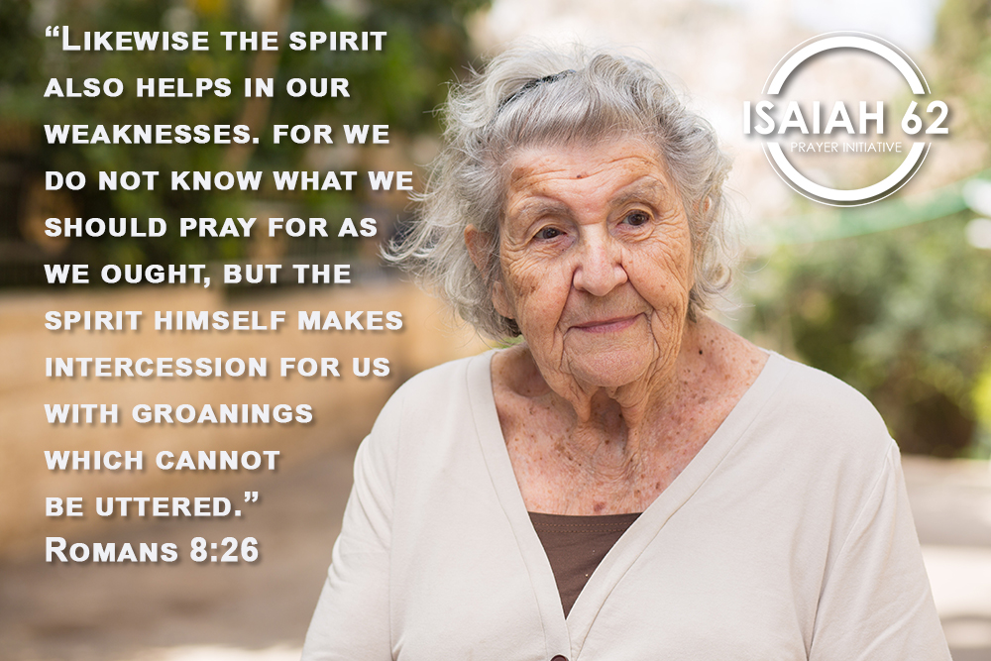

Dear prayer partners,
I recently had an unusual encounter with someone that left a lasting impression on me. Arriving at work one morning, I was pulling into a parking lot behind our Embassy building where I noticed a lady in a wheelchair blocking my way. After waiting for a moment, it was clear she was not going to move. So I left my vehicle and politely asked if I could help her move to the edge of the driveway. She was waiting for a taxi and insisted she could move herself. However, she was struggling to go forward on her own, so I reached out to assist her. This upset the dear lady very much. She began to cry and tell me very loudly that she did not want to be treated as a disabled person. “I am not handicapped,” she insisted between tears. I backed off and apologized for any offense to her.
Life has a way of wounding us all, and sometimes we have trouble accepting it. We often are unaware of the scars we carry and just how deep they can run. But the Bible is clear that we all have disabilities in one way or another. In fact, the Apostle Paul says we are all handicapped in spiritual terms.
“Likewise the Spirit also helps in our weaknesses. For we do not know what we should pray for as we ought, but the Spirit Himself makes intercession for us with groanings which cannot be uttered.” (Romans 8:26)
Here, the word “weaknesses” is also translated as “infirmities”. In the original Greek, it is astheneia – which means “infirmed,” “feebleness,” “sickness” or “diseased.” We all have it in some measure, whether we admit it or not. Our spirits are wounded, our spiritual senses are dulled, our faith is weak, and only by yielding to the work of the Holy Spirit in our lives can we overcome these limitations. And this work is primarily carried out in prayer.
Now the rest of Romans chapter eight is very encouraging. Paul assures us that the Holy Spirit knows our weaknesses and intercedes for us according to the will of God (v. 27); that if God is for us, no one can stand against us (v. 32); that no “tribulation, or distress, or persecution, or famine, or nakedness, or peril, or sword” can separate us from the love of God (v. 36); and that “we are more than conquerors” in Christ (v.37).
We are transformed from feeble souls to mighty conquerors! But this only happens as we yield to the Holy Spirit in prayer.
As we join together in prayer this month, may we allow the Holy Spirit to intercede for us and for all the other prayer needs listed below. He knows our flaws and limitations. He knows the needs of Israel and the surrounding nations. And He knows how the Father wants to answer them according to His will.
Thank you for being part of our Isaiah62 prayer movement!
Blessing from Jerusalem!
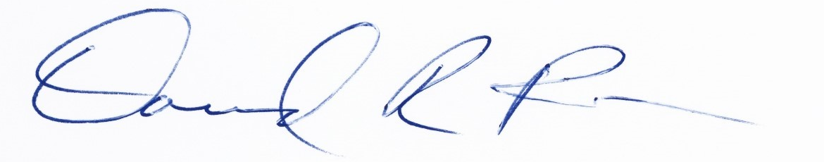
David Parsons
Vice President and Senior Spokesman
International Christian Embassy Jerusalem

PRAYER POINTS
For September 2018
The next day of prayer and fasting in our Isaiah 62 Global Prayer Campaign will be on Wednesday, 5 September 2018. Please join us!
Pray with us accordingly:
- Prayer for Israel

Calm in the Gaza Strip
After months of weekly clashes, rocket attacks and fire balloons from Gaza, the Israeli government and IDF decided to close the border with Gaza. The Palestinian attacks had left thousands of acres of farmland burned. Hamas also came under outside pressure to rein in their futile arson attacks and violent “March of Return” protests. As a result, over the past couple of weeks the Gaza border has been relatively quiet. Let us thank God for the diminished hostility and pray that this calm would be a lasting one.

“He makes peace in your borders, and fills you with the finest wheat.” (Psalm 147:14)

“In righteousness you shall be established; You shall be far from oppression, for you shall not fear; And from terror, for it shall not come near you. Indeed they shall surely assemble, but not because of Me. Whoever assembles against you shall fall for your sake.” (Isaiah 54:14-15)
Military draft in Israel
Israel is a country with a citizens’ army, as every family is expected to send their sons and daughters to the IDF to defend the nation. From the beginning, the ultra-Orthodox were granted exemptions from military service as long as they were enrolled in yeshiva studies. This has always caused widespread resentment from the rest of Israeli society. Over recent months, yet another law was proposed to give the Israeli military the right to draft young men and women from the ultra-Orthodox community. Although, the Haredi parties are resisting and threatening to bring down the governing coalition if the law passes.

Please pray that brotherly love would prevail in the hearts of all Israeli citizens, so that all of society contributes fairly to the burden of defending and building the nation. Pray that the Israeli government would find the right solution to this decades-old problem of unfair exemptions for the ultra-Orthodox.

“Take a census of all the congregation of the children of Israel, by their families, by their father’s houses, according to the number of names, every male individually, from twenty years old and above – all who are able to go to war in Israel. You and Aaron shall number them by their armies. And with you there shall be a man from every tribe, each one the head of his father’s house.” (Numbers 1:2-4)

Contaminated water in the Upper Galilee
The fresh water tributaries to the upper Jordan river coming down from the Golan Heights have been contaminated over recent weeks. The cause of the contamination was an outbreak of bacteria similar to meningitis, while a new outbreak has been linked to E. coli. So far, dozens of Israelis have been infected and suffered serious symptoms. Please pray that the streams and springs in the Golan and Upper Jordan would be completely cleansed of any harmful bacteria.

“So he cried out to the Lord, and the Lord showed him a tree. When he cast it into the waters, the waters were made sweet.” (Exodus 16:25)
- Prayer for the Nations

Israel readies for UN showdown
Prime Minister Benjamin Netanyahu met with the leaders of the three Baltic states. More meetings with national leaders are ahead, as Israel prepares for the Opening Assembly of the United Nations in New York in late September. Arab states are expected to push for a UN condemnation of Israel over its nation-state law. Meanwhile, several key European countries are defying US sanctions and endangering Israel by trying to salvage the troubled nuclear deal with Iran. Please pray for world leaders to take a courageous, moral stand for Israel at the UN assembly, and that the EU would finally decide to confront Iran’s genocidal plot against Israel.

“Arise, O Lord, Do not let man prevail; Let the nations be judged in Your sight.” (Psalm 9:19)
“When a man’s ways please the Lord, He makes even his enemies to be at peace with him.” (Proverbs 16:7)

North Korea/ US negotiations
The United States is still in negotiations with North Korea to solidify an agreement to denuclearize the Korean peninsula. North Korea stated they will not significantly advance toward nuclear disarmament before the US declares peace with Pyongyang. NK’s ruler Kim Jong-un is demanding the US move most of the way toward peace before he makes further dramatic denuclearization moves. Let us pray that the Lord would remove whatever is delaying the North Koreans from dismantling their nuclear weapons program.

“Therefore let us pursue the things which make for peace and the things by which one may edify another.” (Romans 14:19)

- Prayer for the ICEJ

Feast of Tabernacles
We will be hosting our annual Feast of Tabernacles celebration from 23-28 September. We are expecting God to move powerfully again this year, as Christians from all around the world come together in Jerusalem to celebrate God’s Feast. Please pray that the Lord would give an increased measure of energy, wisdom and insight to the staff and team members we prepare for this spectacular celebration. Pray for the Holy Spirit to be present in power and might at the Feast, for God to manifest Himself in glorious ways, and that many lives would be touched and changed forever during this Feast. May it be the best one yet!

“That the God of our Lord Jesus Christ, the Father of glory, may give to you the spirit of wisdom and revelation in the knowledge of Him.” (Ephesians 1:17)

ICEJ Headquarters Building
Please continue to pray for the purchase of the ICEJ Headquarters building
here in Jerusalem. We have been in negotiations with the government of the Ivory Coast over acquiring the ICEJ building in Jerusalem for more than a year now. Let us join together and ask the Lord to answer our prayers to release the building and property into our hands for the Kingdom of God.
“If you then, being evil, know how to give good gifts to your children, how much more will your Father who is in heaven give good things to those who ask Him!” (Matthew 7:11)

Thank you for joining with us in prayer!

