ISAIAH 62 PRAYER INITIATIVE
Prayer Letter for Week 1 of January 2019

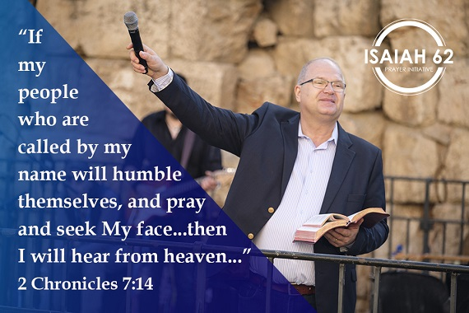
Dear prayer partners,
Each year at the ICEJ, we start off the new year with a month of prayer and seeking the Lord from Jerusalem. In 2 Chronicles 7:14 we read why this is so powerful, transformational, and capable of changing entire nations: “… if My people who are called by My name will humble themselves, and pray and seek My face, and turn from their wicked ways, then I will hear from heaven, and will forgive their sin and heal their land.”
First of all, notice that in God’s eyes the answers for national problems do not lay with its presidents and governments. God says the answer lays with “my people that are called by my name…”. God is not looking for change in government but for change in the church. The change in His people is what brings change in the nations. As his people, God expects us to do four things:
- Humble Ourselves. Pride is one of the main character traits that repel God’s presence. God resists the proud. Therefore, Peter admonishes us to humble ourselves under the mighty hand of God to find help in our time of need. There are many ways we can humble ourselves, however, God defines humility in the way we deal with Him and with our neighbors (see Isa 58).
- Pray. God wants to hear our prayers. John Wesley once said, “God does nothing except in response to believing prayer.” Jesus encourages us to pray and he promises in John 14:13: ”And whatever you ask in My name, that I will do, that the Father may be glorified in the Son.”
- Seek the Face of God. We seek him in prayer with an attitude of perseverance. Seeking his face means we continue to pray, seek and knock until we receive the needed breakthrough. It reflects an attitude of our hearts and minds to hunger and thirst for God in a dry and barren land (Ps 63:1f).
- Turn From Our Wicked Ways. Many of our problems are the result of our own lifestyle. Don’t expect a breakthrough in your life if you are living in sin. Use these first days of the year to ask the Lord to search your heart, and if you already know that you need to change areas of your life, then don’t procrastinate. Repent and change now.
God tells us that if we follow this pattern “I will hear from heaven.” He will take notice of you and you will experience an open heaven.
“I will forgive their sin!” The forgiveness of our sin is the essential need for all mankind. God says in Isaiah 59:1-2, “Behold, the Lord's hand is not shortened, that it cannot save; … but your iniquities have separated you from your God…” We should never forget that it is only because of the blood of Jesus that allows us to draw near into God’s presence. As we confess our sins and repent, he will forgive and answer our prayers.
The final result is powerful: “I will heal their land!” This also applies to your personal territory of your family, your church, and your own life. If you need divine intervention, I encourage you to prayerfully consider these points as we begin this new year. I know that God will hear you because that is his promise to us.
Please join us in prayer everyday for the month of January, especially every Wednesday, as we pray here in Jerusalem for Israel, the nations and the ministry that God gave us here at the ICEJ.
May the Lord bless you mightily as you seek his face in 2019!
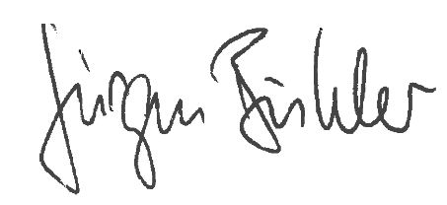
Jürgen Bühler
President
International Christian Embassy Jerusalem

PRAYER POINTS
For Week 1 of January 2019
The next day of prayer and fasting in our Isaiah 62 Global Prayer Campaign will be on Wednesday, 2 January 2019. Please join us!
- Pray for the ICEJ
ICEJ Headquarters Building
By the time you read this, most likely the ICEJ will have signed a rental contract for a property that will serve as our new home here in Jeruslaem. However, we feel very strongly that the Lord wants us to not just lease but to own our own property here in Jerusalem. We pray that the Lord will lead us in the right direction and provide the funds for this major move. Please stand with us in faith believing that the Lord will provide a building for us that will help us represent Christians around the world in a worthy manner.
“So it shall be, when the Lord your God brings you into the land of which He swore to your fathers, to Abraham, Isaac, and Jacob, to give you large and beautiful cities which you did not build, houses full of all good things, which you did not fill, hewn-out wells which you did not dig, vineyards and olive trees which you did not plant—when you have eaten and are full—” (Deuteronomy 6: 10-11)
“Then they cried out to the Lord in their trouble, and He delivered them out of their distresses. And He led them forth by the right way, that they might go to a city for a dwelling place. Oh, that men would give thanks to the Lord for His goodness, and for His wonderful works to the children of men! For He satisfies the longing soul, and fills the hungry soul with goodness. (Psalm 107: 6-9)
Envision Pastors’ Conference
In January of 2019, the International Christian Embassy Jerusalem will be hosting our annual Envision conference for pastors and ministry leaders from around the world. Pray for the planning and decisions still to be undertaken for this gathering, and that the Lord would draw the right pastors to take part in this event.
“Therefore take heed to yourselves and to all the flock, among which the Holy Spirit has made you overseers, to shepherd the church of God which He purchased with His own blood.” (Acts 20:28)
- Pray for the Nations
Embassies Moving to Jerusalem
Pray that more nations will move their Embassies to Jerusalem. There is an increasing number of nations considering moving their embassies to Jerusalem and recognizing Jerusalem as the capital of Israel. For example, there have been recent developments towards this end in Australia and Brazil. Please pray for courage for the leaders of these countries to make the right decisions, and to recognize Jerusalem as the capital of Israel and to move their embassies to Jerusalem.
“There is a river whose streams shall make glad the city of God, The holy place of the tabernacle of the Most High. God is in the midst of her, she shall not be moved;
God shall help her, just at the break of dawn. The nations raged, the kingdoms were moved; He uttered His voice, the earth melted.” (Psalm 46:4-6)
“Why do the nations rage, And the people plot a vain thing? The kings of the earth set themselves, and the rulers take counsel together, against the Lord and against His Anointed, saying, ‘Let us break their bonds in pieces and cast away their cords from us.’ He who sits in the heavens shall laugh; The Lord shall hold them in derision. Then He shall speak to them in His wrath, and distress them in His deep displeasure: ‘Yet I have set My King on My holy hill of Zion.’” (Psalm 2:1-6)
Nations Aligning With Israel
There are new and exciting developments of governments around the world aligning themselves to the nation of Israel like never before. Even Arab nations that have been arch enemies of Israel are recognizing that Israel is a nation which can give them the help and strategies they need to fight Islamic terrorism. African nations also are reaching out to the state of Israel, as they see Israel as a vital partner that can help their countries develop. Please pray for these new diplomatic relations and partnerships to continue and expand. Also pray for Prime Minister Benjamin Netanyahu as he reaches out to these countries.
“Then all peoples of the earth shall see that you are called by the name of the Lord, and they shall be afraid of you. And the Lord will grant you plenty of goods, in the fruit of your body, in the increase of your livestock, and in the produce of your ground, in the land of which the Lord swore to your fathers to give you. The Lord will open to you His good treasure, the heavens, to give the rain to your land in its season, and to bless all the work of your hand. You shall lend to many nations, but you shall not borrow. And the Lord will make you the head and not the tail; you shall be above only, and not be beneath, if you heed the commandments of the Lord your God, which I command you today, and are careful to observe them.” (Deuteronomy 28:10-13)
Pray also 1 Timothy 2:1-2.
‘Palestine’ to Head Key Group at United Nations
On January 1st, the "State of Palestine” will begin serving as chair of the G-77, a powerful bloc of developing nations that now numbers 134 countries and which controls the outcome of most decisions in the United Nations. As head of this powerful alignment of Third World countries for the next year, the Palestinian Authority will be able to drive its anti-Israel agenda as never before. This will likely include even more condemnations of Israel in UN forums, along with other efforts to boycott and delegitimize Israel and falsely brand it as a racist, apartheid state. Please pray that these biased, unfair efforts would be rejected by the G-77 bloc and the majority of nations in the UN, and that Israel’s adversaries would finally be held to account in these international bodies.
“Teach me Your way, O Lord, and lead me in a smooth path, because of my enemies. Do not deliver me to the will of my adversaries; For false witnesses have risen against me, and such as breathe out violence.” (Psalm 27:11-12)
3. Pray for Israel
Protection Over Israel
Please pray for God’s divine protection and intervention over the Israeli people throughout the land, and especially in certain areas of recent attacks and tensions, such as the northern border with Lebanon and the Judea/Samaria region. There have been several deadly terror attacks on civilians in the central Shomron region that appear to be the work of one or more Palestinian terror cells. Pray that the terrorists and those behind them are caught. In addition, Israel continues to search for and destroy terror tunnels dug by Hezbollah underneath the northern border fence with Lebanon. Pray that all of these tunnels would be found and put out of use. Also pray against all the schemes and efforts of the enemy to harm Israel.
“The protector of Israel never dozes or sleeps. The Lord will guard you; He is by your side to protect you. The sun will not hurt you during the day, nor the moon during the night. The Lord will protect you from all danger; He will keep you safe. He will protect you as you come and go now and forever.” (Psalm 121:4-8)
Also pray according to Psalm 91.
Thank you for joining with us in prayer!

