ISAIAH 62 PRAYER INITIATIVE
January 2018 Prayer Letter – Week 4
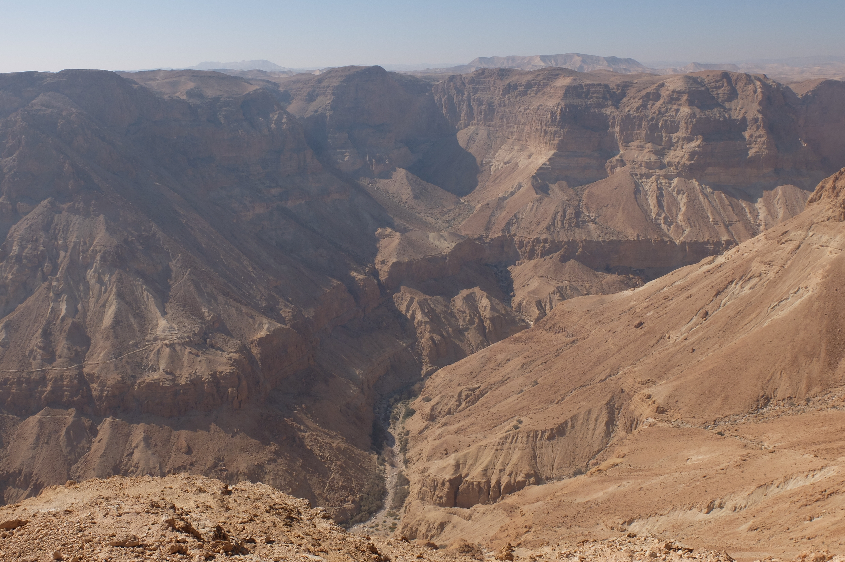
Photo Credit: Matze Immendörfer
Dear Prayer Partners,
As me move into the fourth week of January, let us continue praying for Israel and for God’s redemptive plan to draw closer to fulfillment during this year.
The end of January brings a sobering moment as the world remembers the Holocaust. On January 27, 1945, the Auschwitz death camp was liberated, and the world slowly awoke to the horrors of the genocide against the Jewish people, asking how it was humanly possible.
In fact, much in the history of the Jewish people defies human understanding. It is only when we open the Word of God that we can begin to understand His purpose. The Psalmist says, “When I thought how to understand this, it was too painful for me — until I went into the sanctuary of God; then I understood…” (Ps 73:16)
Now is the time for us to go into the sanctuary. Spend time with God in prayer and in the Word, and He will give you wisdom and understanding.
As we celebrated 50 years of the liberation of Jerusalem last year, we in Jerusalem were full of expectation that the Jubilee year would mark the beginning of a new era, a new phase in God’s dealing with Israel. And indeed, the declaration in December by President Trump opened the door for a change. Pray for your nations that they would follow the lead of the USA and join the few courageous nations which already announced that they, too, recognize Jerusalem as the capital of Israel and plan to move their embassies there.
We can clearly see from the prophetic Scriptures that God is dealing not only with the people of Israel but also with the Land of Israel. Already at the beginning, when He made the covenant with Abraham, He promised him both offspring and land. We have seen throughout history how the enemy tried to destroy the offspring, and the Holocaust was but a culmination of a long and painful series of pogroms and persecution.
The enemy has also tried to erase any Jewish connection to the Land. It was renamed, occupied by invaders, and trampled upon by Gentile empires. Even today, the world community, through UN resolutions, blatantly denies Jewish history. I believe that it has spiritual significance, and that a time is coming when the attitudes of the nations toward the Land will play an increasingly important role in God’s eyes.
He is jealous for His land (Joel 2:18), and He will judge the nations because they divided His land (Joel 3:2). His jealousy burns against the nations which took His land for themselves (Ezek 36:5). These are powerful statements, therefore, let us pray and study the Word to better understand the importance of both the Jewish nation and their land in God’s plan for the whole world.
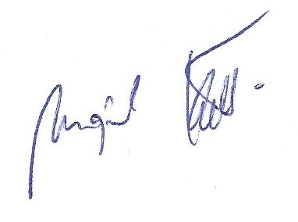
Shalom from Jerusalem,

Mojmir Kallus
Vice President – International Affairs
International Christian Embassy Jerusalem
PRAYER POINTS
For January 2018 – Week 4
The next day of prayer and fasting in our Isaiah 62 Global Prayer Campaign will be on Wednesday, January 24th, 2018. Please join us!

Prayer Focus for the Fourth Week of January 2018
Please focus on the following areas of need in this fourth week of our special January 2018 prayer vigil in the Isaiah 62 Prayer Campaign. Also, please let us know about your needs and how God has answered your prayers! Send a short email to prayer@icej.org or find us on facebook.com/ICEJofficial to let us know you are praying and fasting with us.
- Prayer for Israel and the Nations

Please pray for the political situation in Bolivia and for the freedom of the Church. The government in Bolivia is planning to change the penal system enforcing a penalty of 7-12 years in prison for the recruiting of people to join religious organizations or places of worship. Let us please pray that this plan of the enemy will be annulled and the role of the Church in Bolivia will be strengthened!

“But the Lord stood with me and strengthened me, so that the message might be preached fully through me, and that all the Gentiles might hear. Also I was delivered out of the mouth of the lion.”(2 Timothy 4:17)

“For You have armed me with strength for the battle; You have subdued under me those who rose against me.” (2 Samuel 22:40)

- Prayer for the Middle East
Please pray for the Iranian believers undergoing great persecution for the faith. Early 2018 saw angry, sometimes violent, protests breaking out against the clerical regime in Iran. Elam, an Evangelical ministry which reaches out to Iran and has many contacts in the large and rapidly growing underground churches there, posted a notice on 4 January saying; “We urge people to intercede for the righteousness and peace of Christ to rule all over Iran.” It went on to request prayer against bloodshed in any future protests, freedom for the Iranian people and to build up the Body of Messiah inside this strategically important country.

“Remember the prisoners as if chained with them—those who are mistreated—since you yourselves are in the body also.” (Hebrews 13:3)

“I thank my God upon every remembrance of you, always in every prayer of mine making request for you all with joy, for your fellowship in the gospel from the first day until now, being confident of this very thing, that He who has begun a good work in you will complete it until the day of Jesus Christ.” (Philippians 1:3-6)

- Prayer for the ICEJ
Over 200 pastors and leaders are gathering in Jerusalem this week for the annual ICEJ Evision Pastors and Leaders Conference from January 22-25. Please pray that God reveals His heart for Israel, Jerusalem, the Jewish people, the nations, and what He is doing in this new year to all of these leaders to then be able to impart to their realms of influence. Please pray for the staff at the ICEJ to be unified in what God is revealing to us in this month to then move forward together into this year that we are daring to dream with God!

“I am the Lord, that is My name; And My glory I will not give to another, Nor My praise to carved images. Behold, the former things have come to pass, And new things I declare; Before they spring forth I tell you of them.”(Isaiah 42:8-9)

“Let your eyes look straight ahead; fix your gaze directly before you. Give careful thought to the paths for your feet and be steadfast in all your ways. Do not turn to the right or the left; keep your foot from evil.” (Proverbs 4:25-27 NIV)
Thank you for joining with us in prayer!

