ISAIAH 62 PRAYER INITIATIVE
October 2018 Prayer Letter
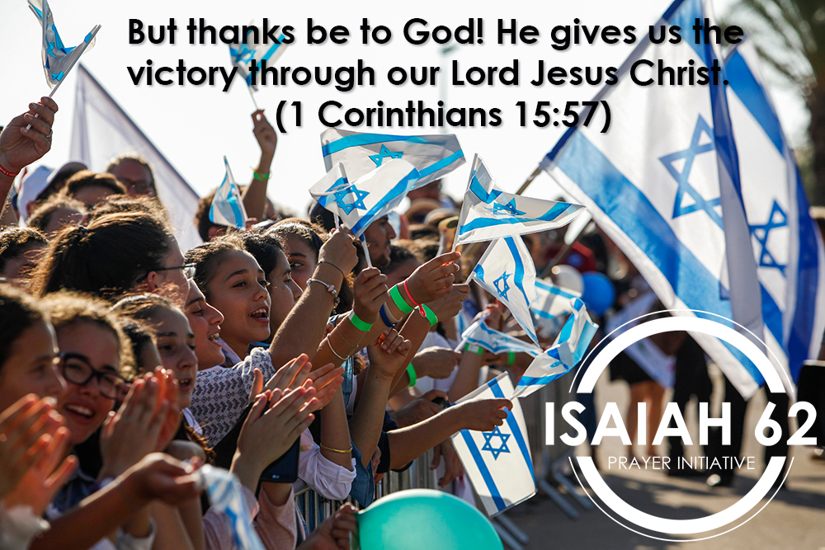
Dear prayer partners,
Thank you for joining us in prayer for Israel and the Middle-East. We just finished celebrating the Fall Feasts, which speak of God’s redemption, faithful provision, and return.
This season began with Rosh Hashanah or the biblical Feast of Trumpets. In Judaism, the trumpet sound is a call to repentance, so on this day they sound the trumpet which begins the ten Days of Awe or repentance. After these days of repentance, we came to Yom Kippur, which is the Day of Atonement. Yom Kippur is a day of fasting from sundown to sundown. After this time of repentance and forgiveness, we celebrated Sukkot or the Feast of Tabernacles.
We had a wonderful celebration at the ICEJ Feast of Tabernacles, as we gave our Lord thanks for 70 years of the rebirth of His nation of Israel. Sukkot is the Feast of the Lord, where He commands joy because it is a time to celebrate His provision and His future eternal dwelling with mankind.
Therefore, as we turn to the Lord in prayer, let us do so with thankful hearts. We encourage you to reflect on this year and give thanks to God for His abundant provision and all the good He has done in your life.
“But thanks be to God! He gives us the victory through our Lord Jesus Christ.” (1 Corinthians 15:57)
Thank you for being part of our Isaiah62 prayer movement!
Shalom from Jerusalem!
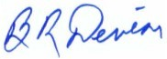
Barry R Denison
Vice President of Operations
International Christian Embassy Jerusalem

PRAYER POINTS
For October 2018
The next day of prayer and fasting in our Isaiah 62 Global Prayer Campaign will be Wednesday, 3 October 2018. Please join us!
Pray with us accordingly:
- Prayer for Israel

Movement on Ethiopian Aliyah
After many long months of delays, it appears the Israeli government is now ready to approve another group of 1,000 Ethiopian Jews to make Aliyah to Israel. The ICEJ stands ready to sponsor the flights for these Jews separated from their families in Israel.
Please pray that the final Israeli government approval will come quickly, along with the budget needed to absorb these very deserving new immigrants. And pray the ICEJ will have all the funds needed to sponsor their flights home to Zion.
“I will say to the north, ‘Give them up!’ And to the south, ‘Do not keep them back!’ Bring My sons from afar, and My daughters from the ends of the earth…” (Isaiah 43:6)
Securing Israel’s Northern Border
As the war in Syria appears to be coming to a close, the Russian government and military have entrenched themselves deeply in the fate of that war-torn country. This means new challenges in relations between Russia and Israel, as Jerusalem seeks to maintain its recent cooperation with Moscow even as it tries to prevent Iran from gaining a greater foothold in Syria and Lebanon by which to threaten Israel.

Please pray that relations between Russia and Israel would remain stable and cooperative even as Israel works to defuse the increased Iranian threat on its northern borders.

“Surely, LORD, you bless the righteous; you surround them with your favour as with a shield.” (Psalms 5:2)
US challenging the mandate of UNRWA
Earlier this year U.S. President Donald Trump cut $350 million in financial aid to UNRWA, the special Palestinian refugee relief agency in Gaza. Protests and strikes ensued after the agency announced it would cut more than 250 jobs in Gaza and the West Bank and make over 500 other positions part-time, as it seeks to survive crippling financial shortfalls caused by US aid cuts. Now, the US is challenging the way UNRWA defines Palestinian refugees – a move that could wipe off millions of supposed refugees from its rolls.

Please pray that this financial crisis would cause the Palestinian leadership in Gaza and Ramallah to truly turn their hearts towards caring for their own people, rather than wasting their time and resources seeking to destroy Israel. Pray that the US would have success in its efforts to convince the international community to phase out UNRWA and treat Palestinian refugees on the same scale as all other refugees are treated.
“The wicked in his pride persecutes the poor; Let them be caught in the plots which they have devised.” (Psalm 10:2)
“Diverse weights are an abomination to the Lord, and dishonest scales are not good.” (Proverbs 20:23)

- Prayer for the Nations

Antisemitism in Political Circles and on Campuses
Antisemitism continues to be aggressively promoted in the guise of anti-Israelism in two highly influential arenas: in politics, particularly in Britain; and on college campuses. In the US, the BDS movement is doing all it can to ostracize Jewish students.

Please pray that this hateful targeting of Israel and Jewish students through politics and on college campuses would be effectively confronted and come to an end. Pray that people would learn to recognize and reject the irrational hatred known as antisemitism.

“Though an army may encamp against me, my heart shall not fear; Though war may rise against me, in this I will be confident.” (Psalms 27:3)

Sheep and Goat nations:
In Matthew 25, Jesus tells us that in the end times, nations will be separated as sheep nations, who come in line with God’s will and His purposes on earth, and goat nations who do not.

This month lift up your nation and ask the Lord to turn the hearts of your country’s leaders to take a stand and align with God’s will for Israel and for your nation.

“Therefore I exhort first of all that supplications, prayers, intercessions, and giving of thanks be made for all men, for kings and all who are in authority, that we may lead a quiet and peaceable life in all godliness and reverence.” (1 Timothy 2:2)

- Prayer for ICEJ:

ICEJ resources as the year closes:
Please pray that the Lord would release the means for the ICEJ to accomplish the projects and goals the Lord has set before us to do. Ask that every hindrance would be uprooted, every door of provision opened, and that this would be a year which ends with the hallmarks of divine favour over our ministry.

“Give, and it will be given to you: good measure, pressed down, shaken together, and running over will be put into your bosom. For with the same measure that you use, it will be measured back to you.” (Luke 6:38)

Feast of Tabernacles 2018:
We want to thank the Lord for this year’s Feast of Tabernacles, and for all the divine appointments and relationships that were made during this year’s Feast. Let us ask the Lord to breath on every connection that was made and that an increase in eternal fruit would be realized in the coming weeks and months.

“… holding fast to the Head, from whom all the body, nourished and knit together by joints and ligaments, grows with the increase that is from God.” (Colossians 2:19)

Thank you for joining with us in prayer!

